Presentational Markup Language

🎨 What is a Presentational Markup Language?
# Source: AI Source: Provided by: [Data Path: Persons Table -> ID Column: 1, Name_En Column: Motasem Essam] -> From: [Chatgpt (GPT‑5 Mini)] on [1/26/2026]
Presentational markup focuses on how content should appear — its style, layout, color, or formatting — rather than what the content means.

🔹 Key Idea:
# Source: AI Source: Provided by: [Data Path: Persons Table -> ID Column: 1, Name_En Column: Motasem Essam] -> From: [Chatgpt (GPT‑5 Mini)] on [1/26/2026]
Presentational markup tells the system how to display text, not what the text is.
It's all about appearance (bold, italic, font size, color, alignment) — not semantics (heading, title, author, etc.).

📄 Examples of Presentational Markup

🔸 HTML (Old Style):
# Source: AI Source: Provided by: [Data Path: Persons Table -> ID Column: 1, Name_En Column: Motasem Essam] -> From: [Chatgpt (GPT‑5 Mini)] on [1/26/2026]
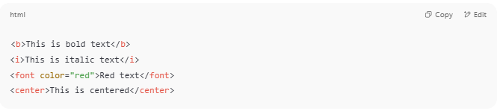
<b>This is bold text</b>
<i>This is italic text</i>
<font color="red">Red text</font>
<center>This is centered</center>

- <b> = make text bold
- <i> = make text italic
- <font> = change font attributes (color, size, etc.)
- <center> = center the content
🛑 Note: These tags are now discouraged in modern HTML — instead we use CSS for presentation.

🖌️ HTML + CSS (Modern Presentational Style)
# Source: AI Source: Provided by: [Data Path: Persons Table -> ID Column: 1, Name_En Column: Motasem Essam] -> From: [Chatgpt (GPT‑5 Mini)] on [1/26/2026]
We separate structure (HTML) and presentation (CSS):
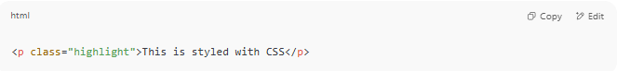
<p class="highlight">This is styled with CSS</p>
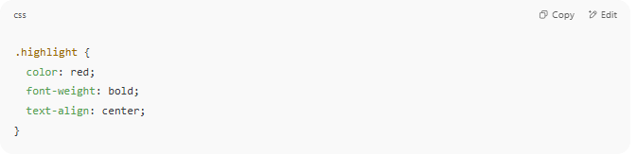

.highlight {
color: red;
font-weight: bold;
text-align: center;
}

🧾 Other Examples of Presentational Markup:
# Source: AI Source: Provided by: [Data Path: Persons Table -> ID Column: 1, Name_En Column: Motasem Essam] -> From: [Chatgpt (GPT‑5 Mini)] on [1/26/2026]
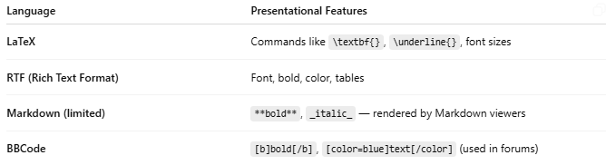
Language | Presentational Features
LaTeX | Commands like \textbf{}, \underline{}, font sizes
RTF (Rich Text Format) | Font, bold, color, tables
Markdown (limited) | **bold**, _italic_ — rendered by Markdown viewers
BBCode | [b]bold[/b], [color=blue]text[/color] (used in forums)

✅ Use Cases of Presentational Markup
# Source: AI Source: Provided by: [Data Path: Persons Table -> ID Column: 1, Name_En Column: Motasem Essam] -> From: [Chatgpt (GPT‑5 Mini)] on [1/26/2026]
- Designing document layout (e.g., resumes, reports)
- Styling web content (with HTML/CSS)
- Creating visually formatted output in simple editors or forums

⚠️ Limitations
# Source: AI Source: Provided by: [Data Path: Persons Table -> ID Column: 1, Name_En Column: Motasem Essam] -> From: [Chatgpt (GPT‑5 Mini)] on [1/26/2026]
- No meaning: Machines can't "understand" what the content is.
- Harder to maintain: Mixing content and style makes documents messy.
- Replaced by CSS in modern web development

Presentational vs Semantic Markup
# Source: AI Source: Provided by: [Data Path: Persons Table -> ID Column: 1, Name_En Column: Motasem Essam] -> From: [Chatgpt (GPT‑5 Mini)] on [1/26/2026]
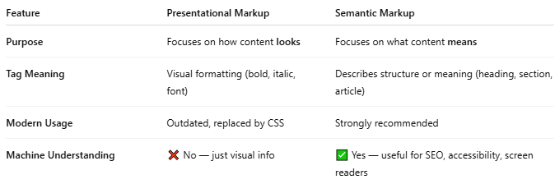
Feature | Presentational Markup | Semantic Markup
Purpose | Focuses on how content looks | Focuses on what content means
Tag Meaning | Visual formatting (bold, italic, font) | Describes structure or meaning (heading, section, article)
Modern Usage | Outdated, replaced by CSS | Strongly recommended
Machine Understanding | ❌ No — just visual info | ✅ Yes — useful for SEO, accessibility, screen readers

🔸 Example 1: Bold Text
# Source: AI Source: Provided by: [Data Path: Persons Table -> ID Column: 1, Name_En Column: Motasem Essam] -> From: [Chatgpt (GPT‑5 Mini)] on [1/26/2026]
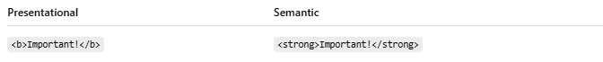
Presentational | Semantic
<b>Important!</b> | <strong>Important!</strong>
- <b> = just bold
- <strong> = important content (can also be read out louder by screen readers)

🔸 Example 2: Italic Text
# Source: AI Source: Provided by: [Data Path: Persons Table -> ID Column: 1, Name_En Column: Motasem Essam] -> From: [Chatgpt (GPT‑5 Mini)] on [1/26/2026]
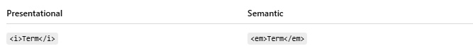
Presentational | Semantic
<i>Term</i> | <em>Term</em>
- <i> = just italic
- <em> = emphasis (semantic meaning — read with emphasis)

🔸 Example 3: Headings
# Source: AI Source: Provided by: [Data Path: Persons Table -> ID Column: 1, Name_En Column: Motasem Essam] -> From: [Chatgpt (GPT‑5 Mini)] on [1/26/2026]
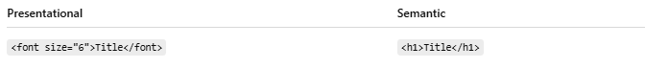

Presentational | Semantic
<font size="6">Title</font> | <h1>Title</h1>
- <font> changes size visually
- <h1> tells the browser: "this is the main heading"

🔸 Example 4: Layout
# Source: AI Source: Provided by: [Data Path: Persons Table -> ID Column: 1, Name_En Column: Motasem Essam] -> From: [Chatgpt (GPT‑5 Mini)] on [1/26/2026]
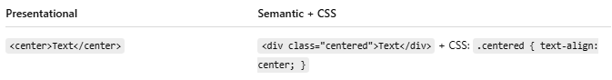
Presentational | Semantic + CSS
<center>Text</center> | <div class="centered">Text</div> + CSS: .centered { text-align: center; }

🧠 Why Semantic Markup Matters:
# Source: AI Source: Provided by: [Data Path: Persons Table -> ID Column: 1, Name_En Column: Motasem Essam] -> From: [Chatgpt (GPT‑5 Mini)] on [1/26/2026]
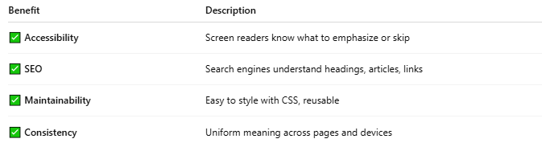
Benefit | Description
✅ Accessibility | Screen readers know what to emphasize or skip
✅ SEO | Search engines understand headings, articles, links
✅ Maintainability | Easy to style with CSS, reusable
✅ Consistency | Uniform meaning across pages and devices

🔹 Side-by-Side Example
# Source: AI Source: Provided by: [Data Path: Persons Table -> ID Column: 1, Name_En Column: Motasem Essam] -> From: [Chatgpt (GPT‑5 Mini)] on [1/26/2026]
HTML Example: Presentational vs Semantic
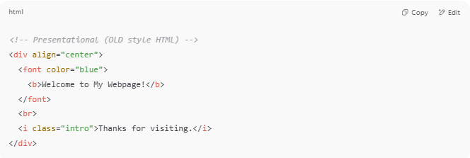
<!-- Presentational (OLD style HTML) -->
<div align="center">
<font color="blue">
<b>Welcome to My Webpage!</b>
</font>
<br>
<i class="intro">Thanks for visiting.</i>
</div>

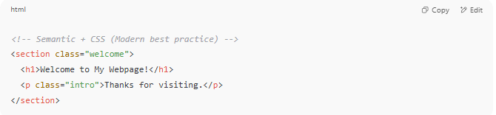
<!-- Semantic + CSS (Modern best practice) -->
<section class="welcome">
<h1>Welcome to My Webpage!</h1>
<p class="intro">Thanks for visiting.</p>
</section>

CSS for Modern Example:
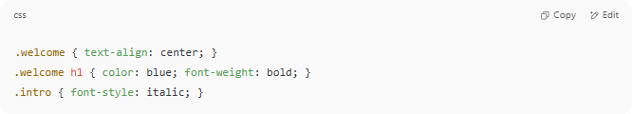
.welcome { text-align: center; }
.welcome h1 { color: blue; font-weight: bold; }
.intro { font-style: italic; }

✅ Why Semantic + CSS is Better
# Source: AI Source: Provided by: [Data Path: Persons Table -> ID Column: 1, Name_En Column: Motasem Essam] -> From: [Chatgpt (GPT‑5 Mini)] on [1/26/2026]
- Enhanced Accessibility: Screen readers understand <h1>, <p>, etc., but struggle with <b>, <i> for structure.
- Better SEO: Search engines prioritize semantically meaningful elements.
- Reusable Styles: Update one CSS rule to restyle your entire site.
- Cleaner HTML: Less clutter in your HTML—focus on content structure, not design.

🔁 Summary
# Source: AI Source: Provided by: [Data Path: Persons Table -> ID Column: 1, Name_En Column: Motasem Essam] -> From: [Chatgpt (GPT‑5 Mini)] on [1/26/2026]
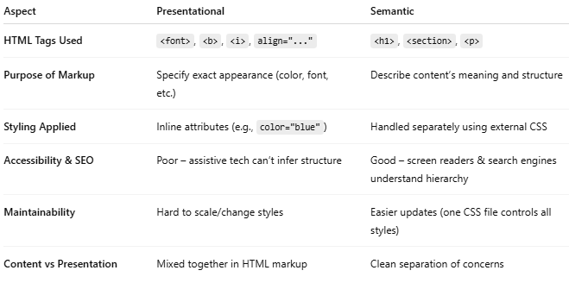

Aspect | Presentational | Semantic
HTML Tags Used | <font>, <b>, <i>, align="..." | <h1>, <section>, <p>
Purpose of Markup | Specify exact appearance (color, font, etc.) | Describe content’s meaning and structure
Styling Applied | Inline attributes (e.g., color="blue") | Handled separately using external CSS
Accessibility & SEO | Poor – assistive tech can’t infer structure | Good – screen readers & search engines understand hierarchy
Maintainability | Hard to scale/change styles | Easier updates (one CSS file controls all styles)
Content vs Presentation | Mixed together in HTML markup | Clean separation of concerns

🔸 Quick Recap
# Source: AI Source: Provided by: [Data Path: Persons Table -> ID Column: 1, Name_En Column: Motasem Essam] -> From: [Chatgpt (GPT‑5 Mini)] on [1/26/2026]
- Presentational markup: tells how things look (e.g. <b>, <i>, <font>)
- Semantic markup: tells what things are (e.g. <h1> for titles, <p> for paragraphs)
- Modern approach: Use semantic tags + CSS, not presentational HTML

🧪 Final Comparison
# Source: AI Source: Provided by: [Data Path: Persons Table -> ID Column: 1, Name_En Column: Motasem Essam] -> From: [Chatgpt (GPT‑5 Mini)] on [1/26/2026]
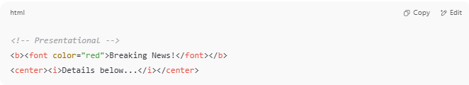
<!-- Presentational -->
<b><font color="red">Breaking News!</font></b>
<center><i>Details below...</i></center>

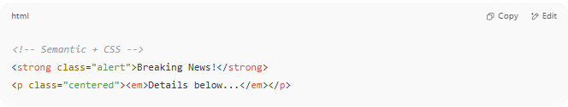
<!-- Semantic + CSS -->
<strong class="alert">Breaking News!</strong>
<p class="centered"><em>Details below...</em></p>

And CSS:
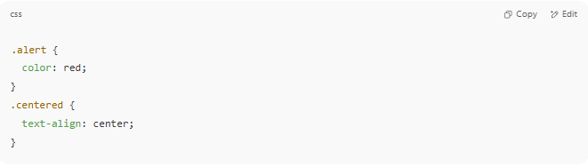
.alert {
color: red;
}
.centered {
text-align: center;
}

